**Information Security**

Zeina Nosseir

Nadine Khoury

Karen Atef

Aly Hussein

**Alert Message:**

This message is displayed to the user when he inserts a wrong username/password.

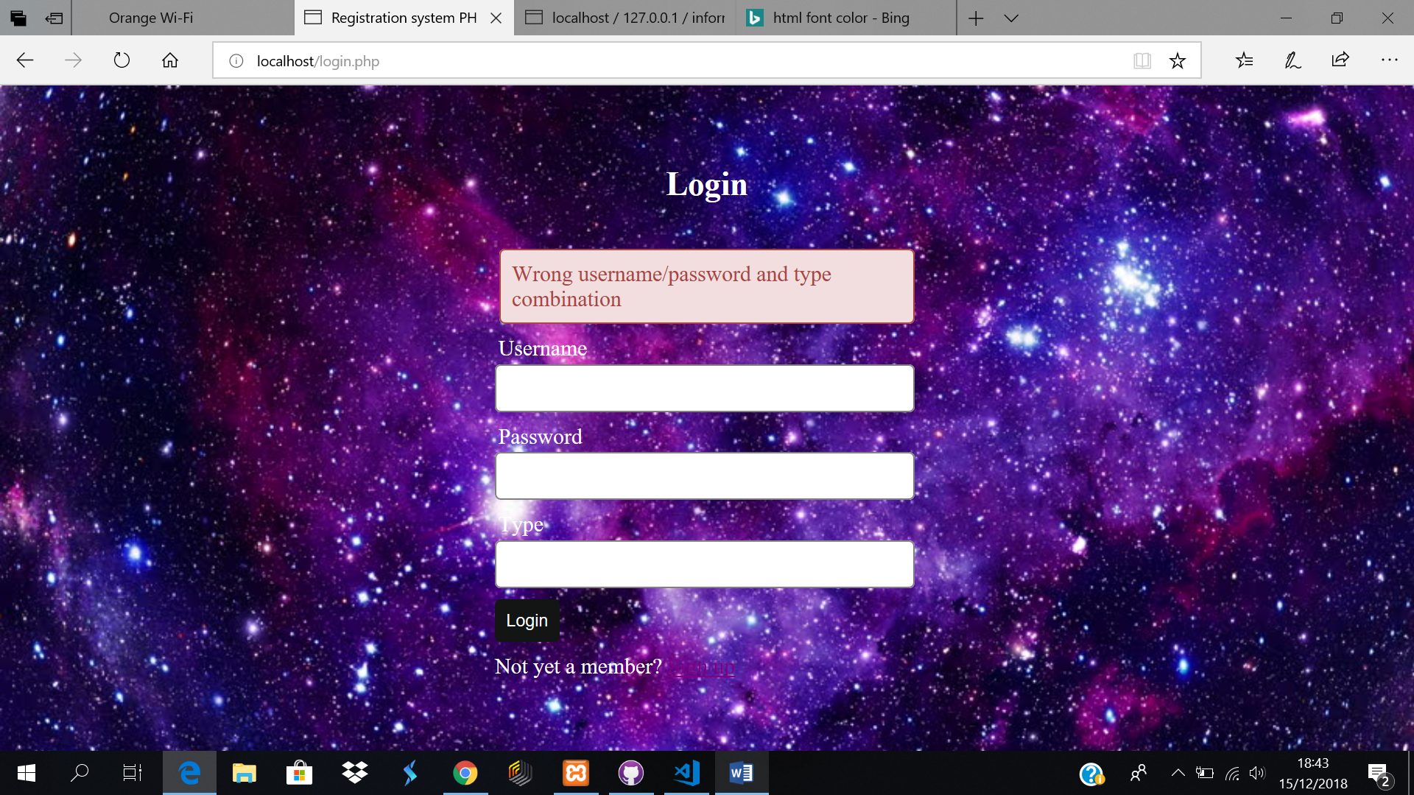

Hashing of password:

Here the password are saved into the data base hashed, to ensure that the security of the user is ensured.

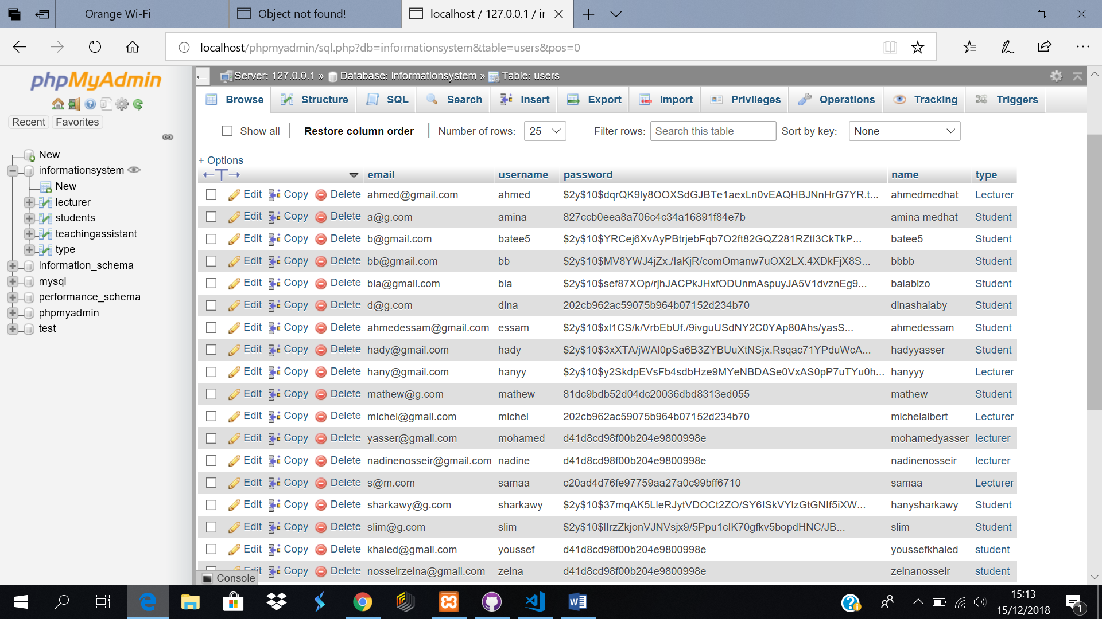

Registration:

Doesn’t allow duplication.

